JMETER SETUP (Ubuntu)
This document provides a complete step-by-step guide to install and configure Apache JMeter on Ubuntu. Follow the instructions carefully to ensure JMeter is installed and working properly on your system.

STEP 1 : CREATING NEW DIRECTORY
1. Open Terminal
2. Create a new parent directory
cmd:
mkdir opt
cd opt/
Create one sub directory
cmd:
mkdir jmeter
The path should be like
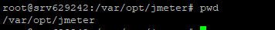

Step 2: Verify or Install Java
Apache JMeter requires Java to run.
cmd:
java -version
If Java is not installed:
cmd:
sudo apt install openjdk-17-jdk
After java installation kindly re-check with this command
cmd:
java –version
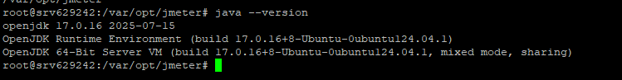

Step 3: Download and Extract JMeter
The directory should inside Jmeter
Mention the Below commands
cmd:
wget https://downloads.apache.org/jmeter/binaries/apache-jmeter-5.6.3.tgz
tar -xvzf apache-jmeter-5.6.3.tgz
The above tar command will extract the file

Step 4: Set Environment Variables
To make JMeter accessible from anywhere, add it to your PATH. Replace the path with where you extracted JMeter.
cmd:
echo 'export PATH=$PATH:/opt/apache-jmeter-5.6.3/bin'
# Path = mention your apache-jmeter path
After this step
cmd:
source ~/.bashrc

Step 5: Verify Installation
Check if JMeter is installed correctly by running this command
cmd:
jmeter -version (or) jmeter –v
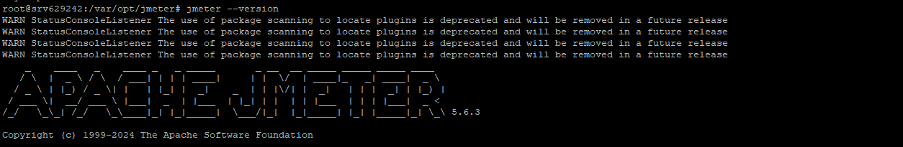

Step 6 : Moving Local JMeter Script File into Server
Just drag the folder from left to right
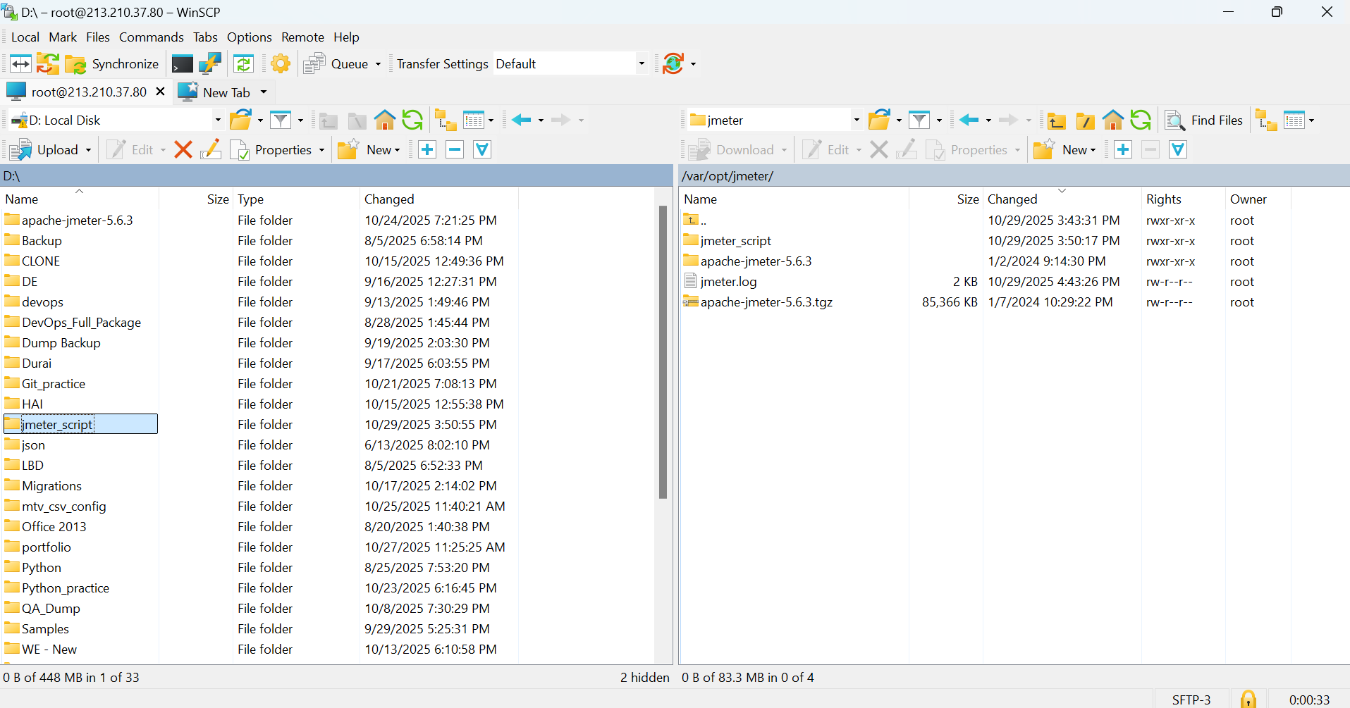

Step 7 : Setting up the local JMeter GUI path
In the csv Data Set Config mention the path of the moved JMeter script folder
Mention the Threads and save the GUI Apache Application in your PC
Then move the jmx file from local to server
Every time When you are changing the threads in the GUI interface in Apache JMeter, you have to move the jmx file from local to server.

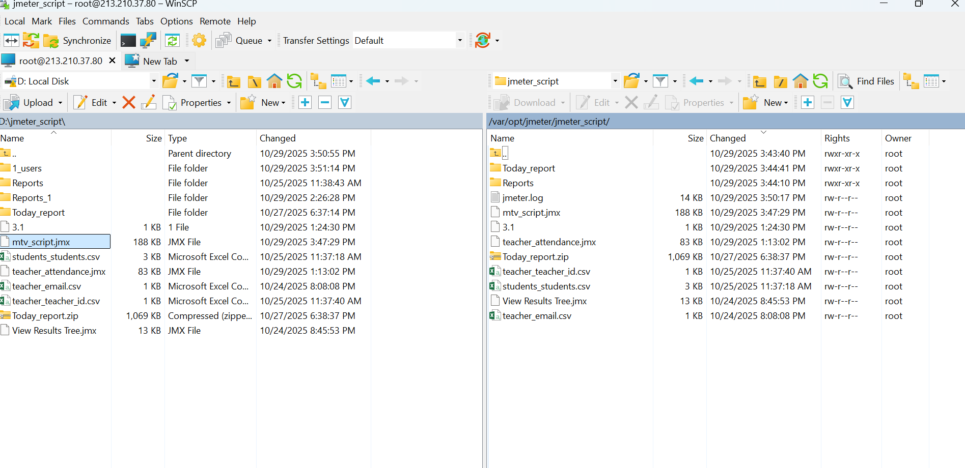

Step 8: Running JMeter in Non-GUI Mode
To execute a test plan in non-GUI mode (recommended for servers or automation),
cmd:
jmeter -n -t "/var/opt/jmeter/jmeter_script/mtv_script.jmx" -l "/var/opt/jmeter/jmeter_script/Reports/jtl_files/1"
-n = Runs JMeter without opening the graphical interface — useful for automation, CI/CD pipelines, or servers.
-t = Specifies the path to your JMeter test plan file.
-l = Defines where JMeter will store the test execution results.
cmd:
jmeter -g "/var/opt/jmeter/jmeter_script/Reports/jtl_files/1" -o "/var/opt/jmeter/jmeter_script/Reports/html_report/1_users"

Step 9: Move the HTML Report Folder from Server to Local
For this "/var/opt/jmeter/jmeter_script/Reports/html_report/1_users" you have to mention the HTML folder path.
Move the HTML report folder from server to local.

